Formula | Total # of  Valence  Electrons | Lewis Structure (2D drawing) | Molecular Structure (3D drawing) | Molecular Geometry (Write name) | Polar or Nonpolar (Circle one)
CH₄ | 8 | 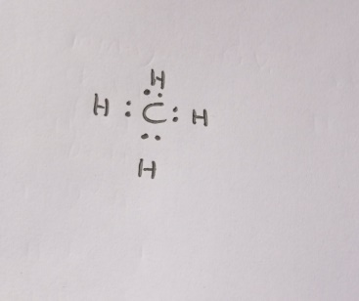 | 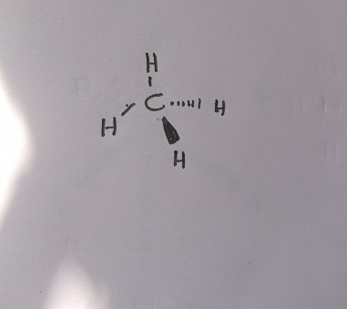 | Tetrahedral | Nonpolar
BF₃ | 6 | 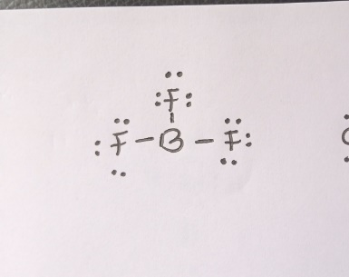 | 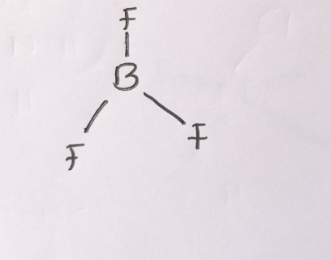 | Trigonal planar | Nonpolar
HCN | 10 | 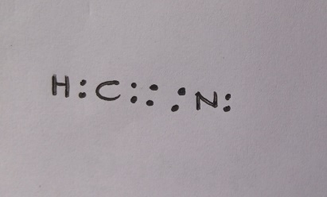 | 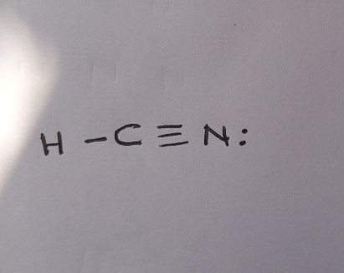 | Linear | Polar
NH₃ | 8 | 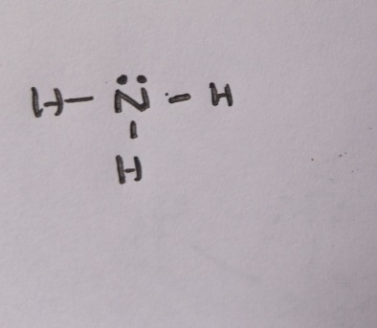 | 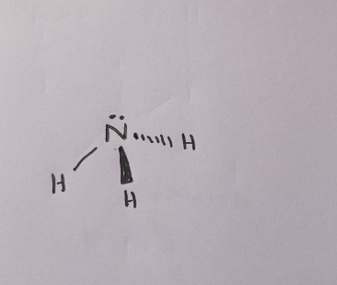 | trigonal pyramidal | Polar
18
Formula | Total # of  Valence  Electrons | Lewis Structure (2D drawing) | Molecular Structure (3D drawing) | Molecular Geometry (Write name) | Polar or Nonpolar (Circle one)
NOF | 18 | 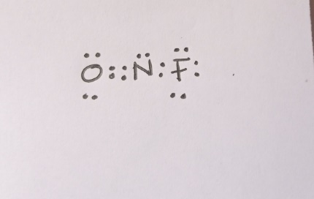 | 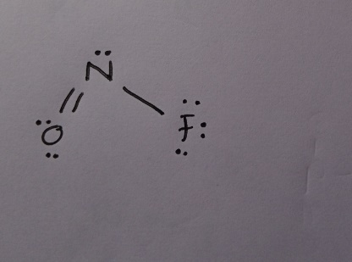 | Bent | Nonpolar
H₂O | 8 | 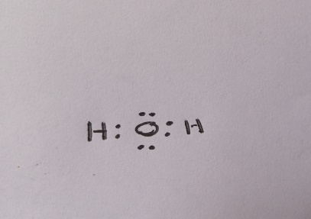 | 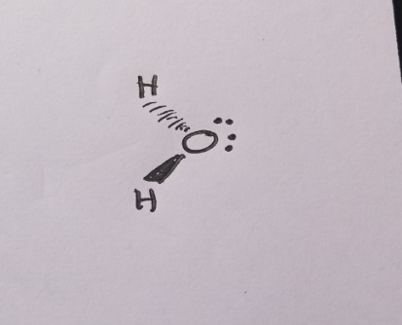 | Bent | Polar
BrF₅ | 42 | 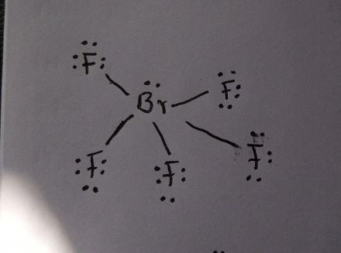 | 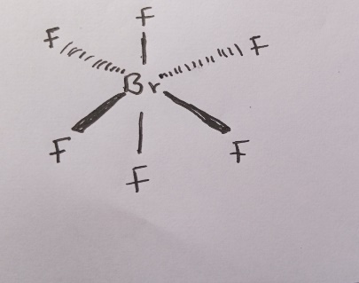 | square pyramidal | Polar
FNO2 | 18 | 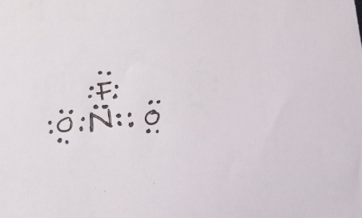 | 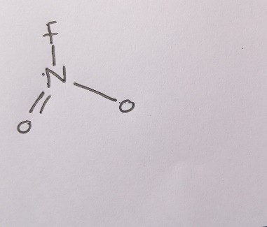 | trigonal planar | Polar

Formula | Total # of  Valence  Electrons | Lewis Structure (2D drawing) | Molecular Structure (3D drawing) | Molecular Geometry (Write name) | Polar or Nonpolar (Circle one)
SF₆ | 48 | 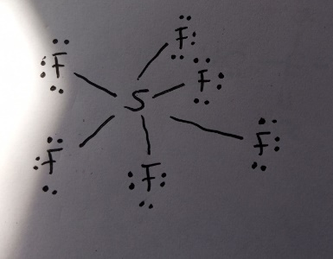 | 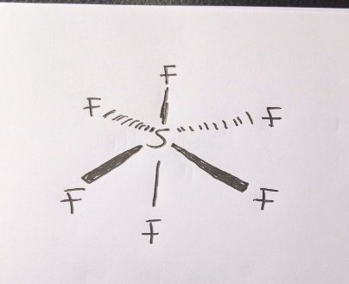 | octahedral | Nonpolar
IF4- | 36 | 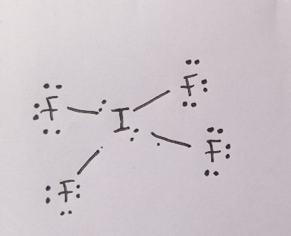 | 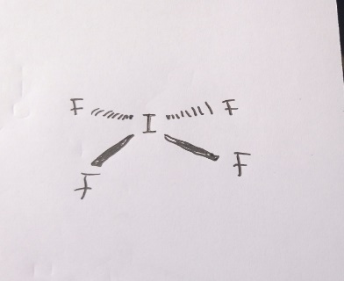 | square planar | N/A  (polyatomic ion)
H3O+ | 8 | 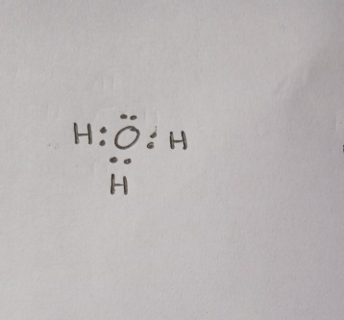 | 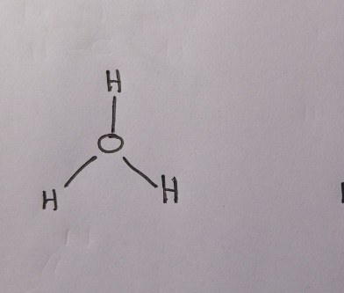 | tetrahedral | N/A  (polyatomic ion)
NH4+ | 8 | 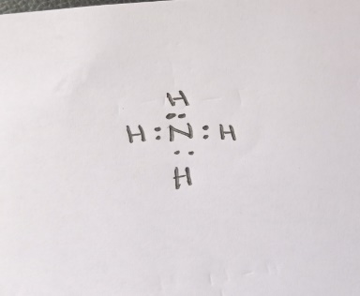 | 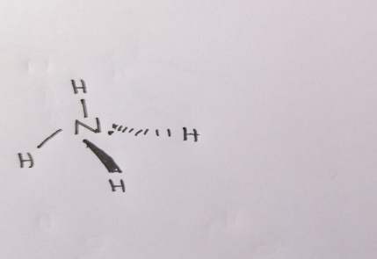 | tetrahedral | N/A  (polyatomic ion)

Formula | Total # of  Valence  Electrons | Lewis Structure (2D drawing) | Molecular Structure (3D drawing) | Molecular Geometry (Write name) | Polar or Nonpolar (Circle one)
ClF₂⁺ | 7 | 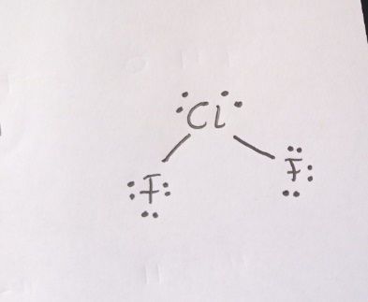 | 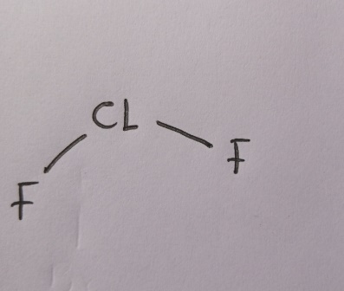 | Bent | N/A  (polyatomic ion)
N3- | 16 | 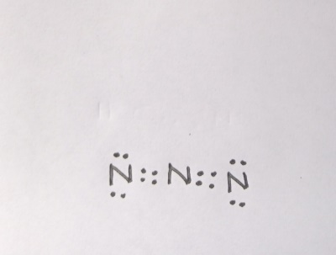 | 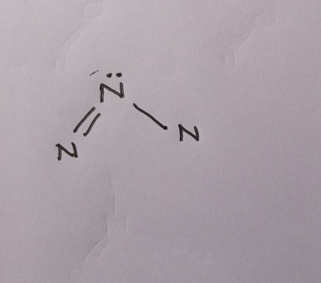 | trigonal pyramidal | N/A  (polyatomic ion)
XeF₅⁺ | 42 | 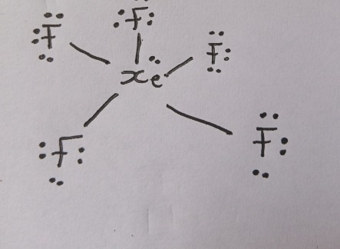 | 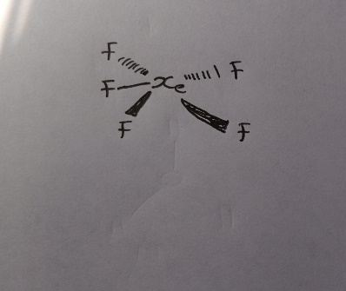 | square pyramidal | N/A  (polyatomic ion)
PO43- | 32 | 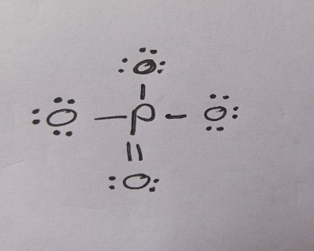 | 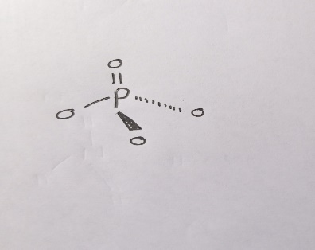 | tetrahedral | N/A  (polyatomic ion)

